Agency Admin Meeting
March 28, 2019
3:00 - 4:30PM
Youth Services

Attendees: Melissa Coloma, Lise Stuart, Kayla Pollard, Mike Fleck, Samantha Sutherland, Danielle Bautista, Vanessa Moya, Diana Johnson, Marie Hickman, Nicole Tarricone, Sandy Young, Mirtha Strugo, Daphne Weller, Tami Kinman, Daniel Dickens, Jordan Rahier, Brandon Nielsen, James Ewell, Foster Martinez, Cara Ashworth, Susanne Fendler, Eva Savage, Bonnie Haight, James Marcroft-Clark, Shannon Smyth, Jeff Wolfe, Leasa Stephens, Anna Gonzales, Dana Petersen-Crabb, Chris Pickering
- Sign in/Introductions
  - Make sure to sign in every meeting
- Agency Highlight – SVDP SSVF
  - Has programs available for veterans
  - Working on implementing a new program by October 1st 2019 called Rapid Resolution (Diversion)
  - Veteran Criteria for Services
    - See Page 5 for Veterans Eligibility Criteria
- ServicePoint update
  - LC Implementation
    - LC is moving forward with our own implementation. In conversation currently about pricing and contracts.
    - This will allow LC to clean up data, reset the ROI function, add new modules and make changes to the system that is best fit for our CoC
  - ServicePoint changes
    - WellSky formerly Mediware has renamed ServicePoint to Community Services. This change current doesn’t show in ServicePoint but they are now referring to it as that on communications and contracts.
    - ServicePoint 6 - We’ve been talking about it and just recently found out it is not happening. Instead of rolling out a brand new product they will be making changes to each module and rolling them out one at a time. Below updates per WellSky Newsletter
      - ShelterPoint – We are currently working on the new and improved ShelterPoint module (new name TBD). This module has been re-designed from the ground up to utilize a modern user interface (see screen shot on Page 6). The module will showcase a reduced number of screens through a consolidated and intuitive dashboard. The check-in process has been simplified through the use of clear data entry steps and enhanced messaging. The module will also feature enhanced usability on smaller desktop screens and tablet-sized devices.
      - Password resets – As a result of customer feedback, we are currently developing functionality that will allow end users to securely reset their password if forgotten or if they exceeded the maximum number of login attempts. This new feature will allow users to restore account access without intervention allowing administrators to focus on more critical tasks.
    - Melissa will be attending the WellSky Boot Camp in July and will hopefully have more information in regards to the updates at the July meeting
  - COFEE
    - 2nd Annual Collaborate Oregon For Everyone Everywhere 2019 is scheduled for May 8th & 9^{th.} This will be at the same location as last year. LC will have 20 available slots. Melissa will send out Registration and Agenda in the next couple of weeks. Registration will be first come, first serve.
- Operation Welcome Home - Veterans Initiative
  - 1 of 10 communities selected to receive technical assistance guidance from Oregon Housing and Community Services in partnership with Oregon Department of Veterans’ Affairs and Cloudburst Group to end veterans’ homelessness.
  - 1 of the goals is to restructure the Veterans by-name list and Coordinated Entry system.
    - The by-name list is dependent on the data entered into ServicePoint. Any clients identified as a veteran their name will show up on the list.
    - Important to add client contact information into ServicePoint for Veteran clients. Outreach worker are having a hard time finding them.
    - Future ServicePoint we are looking at adding the Eligibility module. This would be used to send referrals to multiple programs for one client. A couple important questions can be asked regarding veteran status and if eligible referral could be routed to the by-name list.
- Data Collecting
  - LC Contact Info.
    - It is important to start collecting or verifying this information. Outreach workers and housing programs are having a hard time finding clients when there is no contact or outdated contact information.
      - The 2 pieces of information to collect that would be most helpful is the phone number and email address.
      - The LC Contact Info assessment is located on the bottom of the summary page.
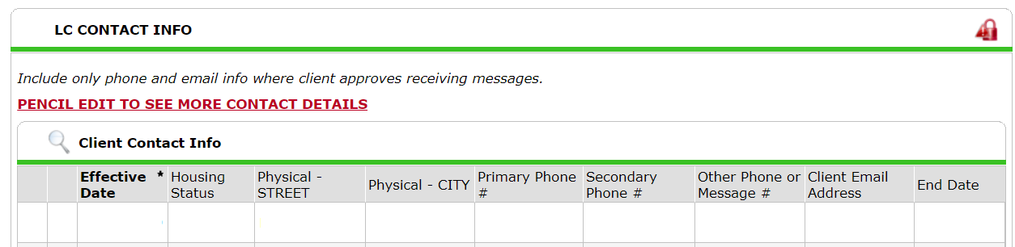
  - Don’t change good data
    - If there is data already there don’t change it to “client doesn’t know”, “client refused” or “Select”
  - Don’t use data not collected
    - Instead of using “Data not collected” leave the field as “Select”. See email sent out to all ServicePoint users on 03/13/19
- Exit forms
  - Clients need to be exited out of the project in ServicePoint when client is no longer receiving services in a project.
  - If you have a program that requires you to keep a paper file with a printed out Entry form than you must also have a printed out Exit form in the file.

- Quarterly reports Due in April
  - Quarterly state reports due by April 10th, CDBG reports due April 25th
  - Reporting period 01/01/19 – 03/31/19
  - Make sure all fixable errors are fixed.
  - Make sure you rename your Caper from a .zip file to a .piz file. LC cannot receive .zip files.
- Next Meeting
  - Next meeting will be in May. Doodle poll will be sent out soon to get it scheduled
  - 1st Place Family will do the Agency Highlight

Vet Criteria for Services
- Minimum service requirement for housing programs: 1 day active duty (for National Guard & Reserve see below) with one of the below character of discharge
- Character of discharge:
- Honorable
- General (under honorable conditions)
- Other than honorable conditions
- Entry level separation
- Bad conduct discharges; under certain conditions

- Veterans Healthcare Administration (VHA) eligible: When a veteran is eligible for VA healthcare = Veteran for VA Purposes
- SSVF Eligible: Both for veterans for VA purposes and those who don’t meet that criteria, but meet the above minimum service requirements
- Some items to consider:
- a veteran is over income for VA healthcare: Not VHA eligible
- a veteran is receiving Non-Service Connected Pension (welfare): VHA eligible
- a veteran is receiving service-connected disability benefits: VHA eligible
- a veteran has National Guard or Reserve service and no activation: Not VHA or SSVF eligible
National Guard & Reserves
- Must have been activated to be eligible for VHA or SSVF:
  - An activation is at least 1 day of service under Title 10 or Title 32 that is not basic training
  - Basic is considered Active duty for training purposes (ADT) when contracted with Guard or Reserve
- Deployed out of state of residence or overseas
- If veteran has a service connected disability = bypasses above requirements and veteran is VHA and SSVF eligible since client would be considered veteran for VA purposes

Items to consider:
- National Guard & Reserve clients often only receive DD-214s for their basic training and advanced training, e.g. AIT, “A School”, & Tech School. These would be included under ADT only. To find out if a client has activations with the National Guard or Reserve, they may need to contact a VSO or homeless veteran advocate to pull their individual records since these may not be indicated on a DD-214

Future ShelterPoint Preview
